Endterm project

(Bazarkulova Aigerim, Rakhmetullina Dariga)

Link to Github: <https://github.com/darigarakh/endtermproject_onlineschool_AITU>

We used these links during this project:

<https://moodle.astanait.edu.kz/pluginfile.php/30333/mod_resource/content/1/Lecture%205%20-%20Exception%20Handling%2C%20JDBC%2C%20Database%20connection.pdf>

<https://web.microsoftstream.com/video/a889587f-f383-4094-a24a-054733e0908e>

<https://moodle.astanait.edu.kz/pluginfile.php/29332/mod_resource/content/1/Lecture%204%20-%20Polymorphism.pdf>

<https://moodle.astanait.edu.kz/pluginfile.php/28467/mod_resource/content/1/Lecture%203%20-%20Inheritance.pdf>

<https://moodle.astanait.edu.kz/pluginfile.php/31564/mod_resource/content/1/Lecture%207%20-%20Language%20Features.pdf>

Screenshots:

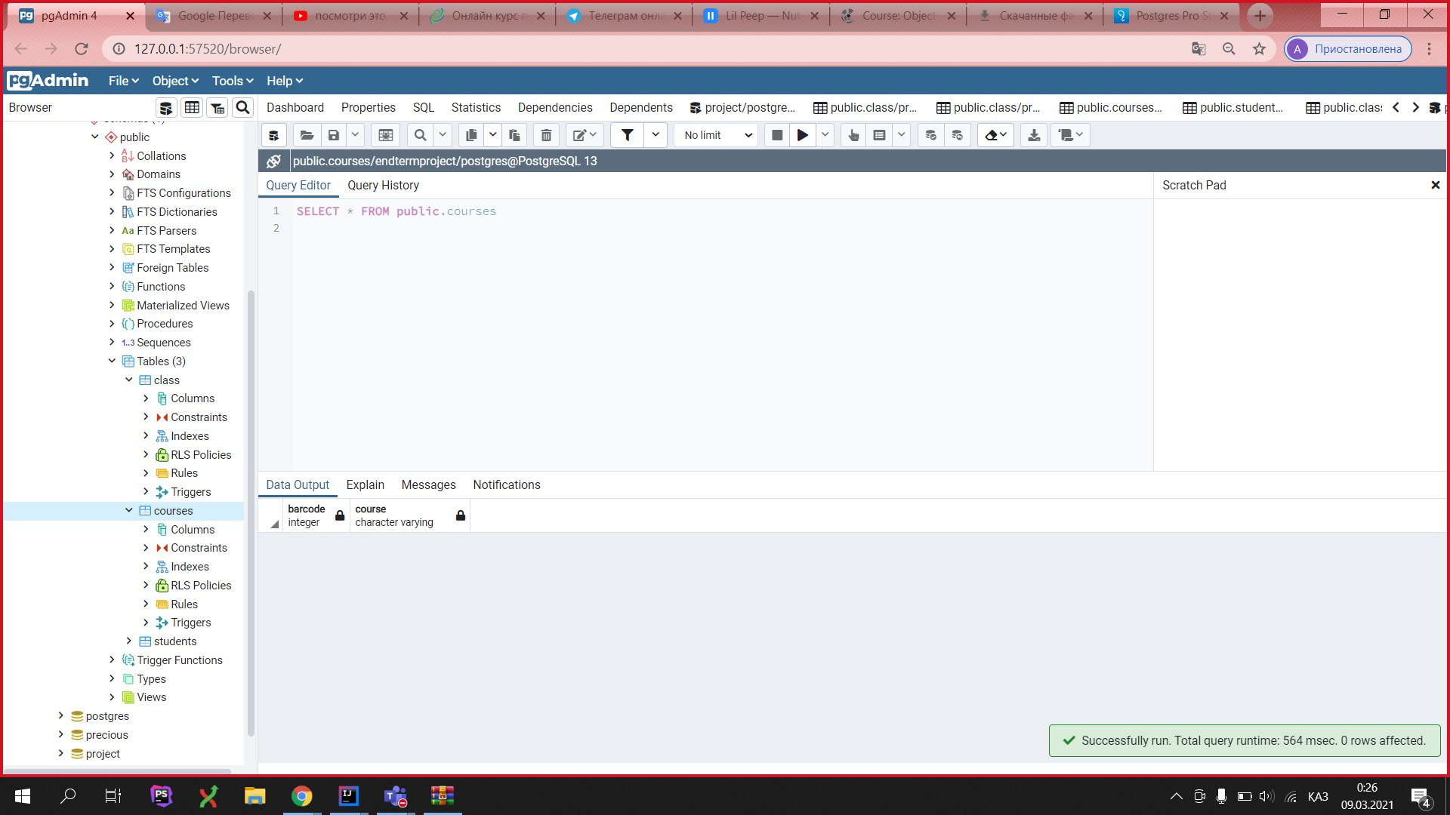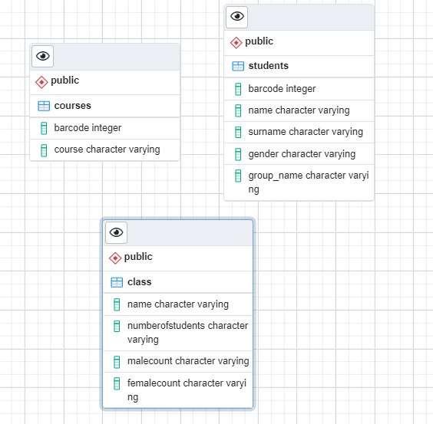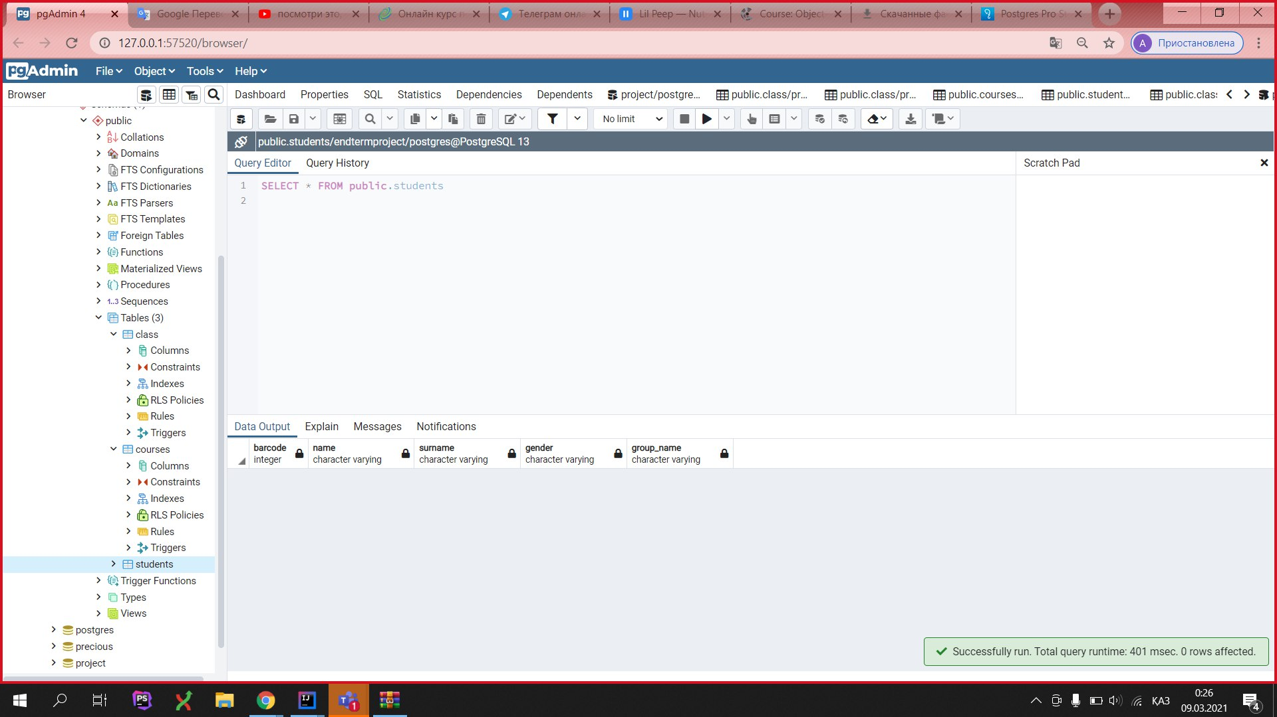

ER diagram:

(Made by Aigerim Bazarkulova)

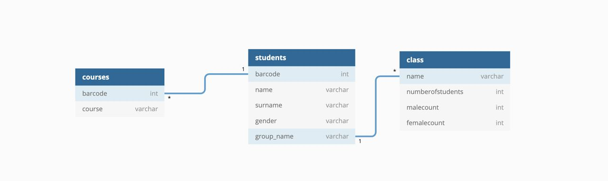

Code:

Group Controller:

(made by Aigerim Bazarkulova)

package com.company.controller;  
  
import com.company.model.entities.Group;  
import com.company.model.entities.Student;  
import com.company.model.repositories.IGroupRepository;  
  
import java.util.ArrayList;  
  
public class GroupController {  
  
 // store repository  
 private final IGroupRepository repository;  
  
 // constructor  
 public GroupController(IGroupRepository repository) {  
 this.repository = repository;  
 }  
  
  
 public Group getGroupInfo(String group){  
 // receieve information from database  
 return repository.getGroupInfo(group);  
 }  
  
 public ArrayList<Student> getStudentsFromGroup(String group){  
 // receieve information from database  
 return repository.getStudentsFromGroup(group);  
 }  
}

Student Controller

(made by Aigerim Bazarkulova)

package com.company.controller;  
  
import com.company.model.entities.Course;  
import com.company.model.entities.Student;  
import com.company.model.repositories.IStudentRepository;  
  
import java.util.ArrayList;  
  
public class StudentController {  
  
 private final IStudentRepository repository; // store repository  
  
 // constructor  
 public StudentController(IStudentRepository repository) {  
 this.repository = repository;  
 }  
  
 public ArrayList<Student> getAllStudents(){  
 // receive info from database  
 return repository.getAllStudents();  
 }  
  
 public void assignToCourse(int barcode, String course){  
 // receive info from database  
 repository.assignToCourse(barcode, course);  
 }  
  
 public ArrayList <Course> getCoursesOfStudent(int barcode){  
 // receive info from database  
 return repository.getCoursesOfStudent(barcode);  
 }  
}

Postgres

(made by Dariga Rakhmetulllina)

package com.company.model.database;  
  
import java.sql.Connection;  
import java.sql.DriverManager;  
import java.sql.SQLException;  
  
public class Postgres implements IDB {  
 @Override  
 public Connection getConnection() throws SQLException, ClassNotFoundException {  
  
 //connect to data base  
 String connectionURL = "jdbc:postgresql://localhost:5432/endtermproject";  
 try {  
 // driver  
 Class.*forName*("org.postgresql.Driver");  
 // return connection with given user and password  
 return DriverManager.*getConnection*(connectionURL, "postgres", "123456");  
 } catch (Exception e) {  
 System.*out*.println(e.getMessage());  
 throw e;  
 }  
 }  
}

IDB

(made by Dariga Rakhmetulllina)

package com.company.model.database;  
  
import java.sql.Connection;  
import java.sql.SQLException;  
  
public interface IDB {  
  
  
 // interface to all databases(postgre mysql etc.)  
 Connection getConnection() throws SQLException, ClassNotFoundException;  
}

Course

(made by Aigerim Bazarkulova)

package com.company.model.entities;  
  
public class Course {  
 String name;  
  
 public Course(String name) {  
 this.name = name;  
 }  
  
 public String getName() {  
 return name;  
 }  
  
 public void setName(String name) {  
 this.name = name;  
 }  
  
 @Override  
 public String toString() {  
 return "Course{" +  
 "name='" + name + '\'' +  
 '}';  
 }  
}

Group

(made by Aigerim Bazarkulova)

package com.company.model.entities;  
  
public class Group {  
 private String name;  
 private int numberOfStudents;  
 private int maleCount;  
 private int femaleCount;  
  
 public Group(String name, int numberOfStudents, int maleCount, int femaleCount) {  
 this.name = name;  
 this.numberOfStudents = numberOfStudents;  
 this.maleCount = maleCount;  
 this.femaleCount = femaleCount;  
 }  
  
 public String getName() {  
 return name;  
 }  
  
 public void setName(String name) {  
 this.name = name;  
 }  
  
 public int getNumberOfStudents() {  
 return numberOfStudents;  
 }  
  
 public void setNumberOfStudents(int numberOfStudents) {  
 this.numberOfStudents = numberOfStudents;  
 }  
  
 public int getMaleCount() {  
 return maleCount;  
 }  
  
 public void setMaleCount(int maleCount) {  
 this.maleCount = maleCount;  
 }  
  
 public int getFemaleCount() {  
 return femaleCount;  
 }  
  
 public void setFemaleCount(int femaleCount) {  
 this.femaleCount = femaleCount;  
 }  
  
 @Override  
 public String toString() {  
 return "Group{" +  
 "name='" + name + '\'' +  
 ", numberOfStudents=" + numberOfStudents +  
 ", maleCount=" + maleCount +  
 ", femaleCount=" + femaleCount +  
 '}';  
 }  
}

Student

(made by Aigerim Bazarkulova)

package com.company.model.entities;  
  
public class Student {  
 private int barcode;  
 private String name;  
 private String surname;  
 private String gender;  
  
 private String group;  
  
 public Student(int barcode, String name, String surname, String gender, String group) {  
 this.barcode = barcode;  
 this.name = name;  
 this.surname = surname;  
 this.gender = gender;  
 this.group = group;  
 }  
  
 public int getBarcode() {  
 return barcode;  
 }  
  
 public void setBarcode(int barcode) {  
 this.barcode = barcode;  
 }  
  
 public String getName() {  
 return name;  
 }  
  
 public void setName(String name) {  
 this.name = name;  
 }  
  
 public String getSurname() {  
 return surname;  
 }  
  
 public void setSurname(String surname) {  
 this.surname = surname;  
 }  
  
 public String getGender() {  
 return gender;  
 }  
  
 public void setGender(String gender) {  
 this.gender = gender;  
 }  
  
 public String getGroup() {  
 return group;  
 }  
  
 public void setGroup(String group) {  
 this.group = group;  
 }  
  
 @Override  
 public String toString() {  
 return "Student{" +  
 "barcode=" + barcode +  
 ", name='" + name + '\'' +  
 ", surname='" + surname + '\'' +  
 ", gender='" + gender + '\'' +  
 ", group='" + group + '\'' +  
 '}';  
 }  
}

IStudentRepository

(made by Dariga Rakhmetullina)

package com.company.model.repositories;  
  
import com.company.model.entities.Course;  
import com.company.model.entities.Student;  
  
import java.util.ArrayList;  
  
// interface for repository  
public interface IStudentRepository {  
  
 public ArrayList<Student> getAllStudents();  
  
 public void assignToCourse(int barocde, String course);  
  
 public ArrayList <Course> getCoursesOfStudent(int barcode);  
}

StudyRepository

(made by Dariga Rakhmetullina)

package com.company.model.repositories;  
  
import com.company.model.database.IDB;  
import com.company.model.entities.Course;  
import com.company.model.entities.Group;  
import com.company.model.entities.Student;  
  
import java.sql.Connection;  
import java.sql.PreparedStatement;  
import java.sql.ResultSet;  
import java.sql.Statement;  
import java.util.ArrayList;  
  
public class StudentRepository implements IStudentRepository {  
  
 // store database  
 private final IDB db;  
  
 // constructor  
 public StudentRepository(IDB db) {  
 this.db = db;  
 }  
  
 // receieve all students from database  
 public ArrayList<Student> getAllStudents(){  
  
 Connection con = null;  
 Statement st = null;  
 ResultSet rs = null;  
  
 ArrayList<Student> res = new ArrayList<>();  
  
 try {  
  
 con = db.getConnection();  
 st = con.createStatement();  
 // sql query  
 rs = st.executeQuery("select * from students");  
  
  
 // add data from all rows  
 while(rs.next()){  
 res.add(new Student(rs.getInt(1), rs.getString(2), rs.getString(3), rs.getString(4), rs.getString(5)));  
 }  
  
 // return data  
  
 return res;  
  
 } catch (Exception e){  
 System.*out*.println(e);  
 } finally {  
 try {  
 con.close();  
 } catch (Exception e){  
 System.*out*.println(e);  
 }  
 }  
  
 return null;  
 }  
  
  
  
 public void assignToCourse(int barcode, String course){  
 Connection con = null;  
 ResultSet rs = null;  
  
 int male = 0;  
 int female = 0;  
  
  
 try {  
 con = db.getConnection(); // connect  
  
 // sql statement  
 String sql = "insert into courses values(?, ?)";  
 PreparedStatement st = con.prepareStatement(sql);  
  
 st.setInt(1, barcode);  
 st.setString(2, course);  
  
  
 // executing statement  
 st.execute();  
  
 } catch (Exception e){  
 System.*out*.println(e);  
 } finally {  
 try {  
 con.close();  
 } catch (Exception e){  
 System.*out*.println(e);  
 }  
 }  
 }  
  
 public ArrayList <Course> getCoursesOfStudent(int barcode){  
 Connection con = null;  
 ResultSet rs = null;  
  
 ArrayList < Course > c = new ArrayList<>();  
  
 try {  
 con = db.getConnection();  
  
  
 // sql query  
 String sql = "select * from courses where barcode=?";  
 PreparedStatement st = con.prepareStatement(sql);  
  
 st.setInt(1, barcode);  
  
 //execute query  
  
 rs = st.executeQuery();  
  
 // add data from all rows  
  
 while(rs.next()){  
 c.add(new Course(rs.getString(2)));  
 }  
  
 // return data  
  
 return c;  
  
  
 } catch (Exception e){  
 System.*out*.println(e);  
 } finally {  
 try {  
 con.close();  
 } catch (Exception e){  
 System.*out*.println(e);  
 }  
 }  
 return null;  
 }  
}

GroupRepository

(made by Aigerim Bazarkulova)

package com.company.model.repositories;  
  
import com.company.model.database.IDB;  
import com.company.model.entities.Group;  
import com.company.model.entities.Student;  
  
import java.sql.Connection;  
import java.sql.PreparedStatement;  
import java.sql.ResultSet;  
import java.sql.Statement;  
import java.util.ArrayList;  
  
public class GroupRepository implements IGroupRepository{  
  
 private final IDB db;  
  
 public GroupRepository(IDB db) {  
 this.db = db;  
 }  
  
 public Group getGroupInfo(String group){  
  
 Connection con = null;  
 ResultSet rs = null;  
  
  
 // store male and female count  
 int male = 0;  
 int female = 0;  
  
  
 try {  
 con = db.getConnection();  
 // sql query  
 String sql = "select * from students where group_name=?";  
 PreparedStatement st = con.prepareStatement(sql);  
  
 st.setString(1, group);  
  
 // execute query  
 rs = st.executeQuery();  
  
  
 // add data from all rows  
 while(rs.next()){  
 // check if male or not  
 if(rs.getString(4).equals("male")){  
 male++;  
 } else {  
 female++;  
 }  
 }  
  
 // return data from database  
  
 return new Group(group, male + female, male, female);  
  
  
 } catch (Exception e){  
 System.*out*.println(e);  
 } finally {  
 try {  
 con.close();  
 } catch (Exception e){  
 System.*out*.println(e);  
 }  
 }  
 return null;  
 }  
  
  
 public ArrayList<Student> getStudentsFromGroup(String group){  
 Connection con = null;  
 ResultSet rs = null;  
  
 ArrayList<Student> res = new ArrayList<>();  
  
 try {  
 con = db.getConnection();  
  
 // sql query  
  
 String sql = "select * from students where group_name=?";  
 PreparedStatement st = con.prepareStatement(sql);  
  
 st.setString(1, group);  
  
  
 // execute query  
 rs = st.executeQuery();  
  
  
 // add data from all rows  
 while(rs.next()){  
 res.add(new Student(rs.getInt(1), rs.getString(2), rs.getString(3), rs.getString(4), rs.getString(5)));  
 }  
  
 // return data  
  
 return res;  
  
  
  
  
 } catch (Exception e){  
 System.*out*.println(e);  
 } finally {  
 try {  
 con.close();  
 } catch (Exception e){  
 System.*out*.println(e);  
 }  
 }  
 return null;  
  
 }  
}

GroupRepository

(made by Aigerim Bazarkulova)

package com.company.model.repositories;  
  
import com.company.model.entities.Group;  
import com.company.model.entities.Student;  
  
import java.util.ArrayList;  
  
// interface for repository  
public interface IGroupRepository {  
 public Group getGroupInfo(String group);  
  
 public ArrayList <Student> getStudentsFromGroup(String group);  
}

Application

(made by Rakhmetullina Dariga)

package com.company.view;  
  
import com.company.controller.GroupController;  
import com.company.controller.StudentController;  
import com.company.model.entities.Course;  
import com.company.model.entities.Group;  
import com.company.model.entities.Student;  
import com.company.model.repositories.GroupRepository;  
import com.company.model.repositories.IGroupRepository;  
import com.company.model.repositories.IStudentRepository;  
import com.company.model.repositories.StudentRepository;  
  
import java.util.ArrayList;  
import java.util.Scanner;  
  
public class Application {  
  
 // declare controllers  
 private final GroupController groupController;  
 private final StudentController studentController;  
  
 public Application(IStudentRepository studentRepository, IGroupRepository groupRepository){  
 groupController = new GroupController(groupRepository);  
 studentController = new StudentController(studentRepository);  
 }  
  
  
 public void start(){  
  
 // starting function  
 System.*out*.println("Hello! Welcome to our school");  
  
 Scanner in = new Scanner(System.*in*);  
  
 while(true){ // endless while loop  
 System.*out*.println("1: I am a teacher");  
 System.*out*.println("2: I am a student");  
 System.*out*.println("#: Exit");  
  
 int choice = in.nextInt();  
  
 if(choice == 1){ // if we are teacher  
 System.*out*.println("1: Show all students");  
 System.*out*.println("2: Show students from group");  
 System.*out*.println("3: Show courses of student");  
 System.*out*.println("4: Show group info");  
 choice = in.nextInt();  
  
 if(choice == 1){ // show all students  
 showAllStudents();  
 } else if(choice == 2){ // show students from group  
 System.*out*.println("Enter group");  
 String group = in.next();  
 showStudentsFromGroup(group);  
 } else if(choice == 3){ // show courses of student  
 System.*out*.println("Enter barcode");  
 int barcode = in.nextInt();  
 showCoursesOfStudent(barcode);  
 } else if(choice == 4){ // show group info  
 System.*out*.println("Enter group");  
 String group = in.next();  
  
 showGroupInfo(group);  
 }  
  
 } else if(choice == 2){ // if we are a student  
 System.*out*.println("Enter your barcode");  
 int barcode = in.nextInt();  
 System.*out*.println("1: Assign to new course");  
 System.*out*.println("2: Show my courses");  
 choice = in.nextInt();  
  
 if(choice == 1){ // assiigning to a new course  
 System.*out*.println("Enter course name");  
 String cname = in.next();  
 studentController.assignToCourse(barcode, cname); // call controller's method assignToCourse(barcode, cname)  
 } else if(choice == 2){ // show my courses  
 showCoursesOfStudent(barcode); // call function showCouresOfStudents which reciecves information from controller  
 }  
 } else {  
 System.*exit*(0);  
 }  
  
 }  
  
 }  
  
 void showAllStudents(){  
 // receive data from controller  
 ArrayList<Student> studs = studentController.getAllStudents();  
  
  
 for(Student to : studs){  
 // output student's data  
 System.*out*.println(to.toString());  
 }  
 }  
  
 void showGroupInfo(String groupname){  
 // receive data from controller  
 Group g = groupController.getGroupInfo(groupname);  
  
 // output group's data  
 System.*out*.println(g.toString());  
  
 }  
  
 void showStudentsFromGroup(String group){  
 // receive data from controller  
 ArrayList < Student > g = groupController.getStudentsFromGroup(group);  
  
 for(Student st : g){  
 // output all student's data  
 System.*out*.println(st.toString());  
 }  
 }  
  
 void showCoursesOfStudent(int barcode){  
 // receieve data from controller  
 ArrayList <Course> c = studentController.getCoursesOfStudent(barcode);  
  
 for(Course to : c){  
 //output all courses  
 System.*out*.println(to.toString());  
 }  
 }  
  
  
  
  
}

Main

(made by Dariga Rakhmetullina)

package com.company;  
  
import com.company.model.database.IDB;  
import com.company.model.database.Postgres;  
import com.company.model.repositories.GroupRepository;  
import com.company.model.repositories.IGroupRepository;  
import com.company.model.repositories.IStudentRepository;  
import com.company.model.repositories.StudentRepository;  
import com.company.view.Application;  
  
public class Main {  
  
 public static void main(String[] args) {  
  
 // to store database  
 IDB database = new Postgres();  
  
 // create repositoriies  
 IGroupRepository groupRepository = new GroupRepository(database);  
 IStudentRepository studentRepository = new StudentRepository(database);  
  
 // create applocation variable  
 Application app = new Application(studentRepository, groupRepository);  
  
 // start our starting function from application  
 app.start();  
  
 }  
  
}

postgreesql

(made by Dariga Rakhmetullina)

create table students ( barcode serial, name varchar, surname varchar, gender varchar, group_name varchar );

create table class (name varchar, numberofstudents varchar, malecount varchar, femalecount varchar);

create table courses (barcode int, course varchar);